The Farmington Libraries
Garmany Online Music Series
presents:

The Modernistics:
Holiday Hits and Other Favorites from the Great American Songbook

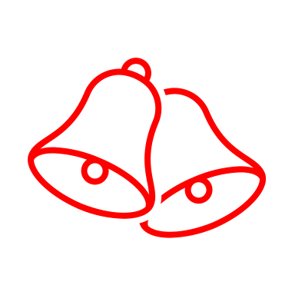
Part I: Swinging Holiday Hits
Ted Powers, guitar, vocals, percussion and tap
Peter H. Bloom, flute ~ Dave Zox, double-bass

Walking in a Winter Wonderland by Felix Bernard
Sleigh Ride by Leroy Anderson and Mitchell Parrish
I’ve Got My Love to Keep Me Warm by Irving Berlin
Let It Snow by Sammy Cahn and Jule Styne
The Christmas Song by Mel Tormé and Bob Wells
Brazilian Sleigh Bells by Percy Faith
Rudolph the Red-Nosed Reindeer by Johnny Marks

Part II: Celebrating the Great American Songbook
Pamela Powers, vocals and tap ~ Ted Powers, guitar and vocals;
Peter H. Bloom, flute ~ Mark Leighton, guitar ~ Dave Zox, double-bass

Sunny Side of the Street by Jimmy McHugh and Dorothy Fields
It’s Only a Paper Moon by Harold Arlen and Yip Harburg/Billy Rose
Somente by Pixinguinha
Bei Mir Bis Du Schoen by Jacob Jacobs and Sholom Secunda
It Don’t Mean a Thing If It Ain’t Got That Swing by Duke Ellington and Irving Mills

This concert is sponsored by the Hartford Foundation for Public Giving

